Music Theory Analysis

Cantique de Jean Racine
Gabriel Fauré

Charlene Blondo
Northern State University
2015

Music Theory Analysis of Cantique de Jean Racine by Gabriel Fauré

To gain a greater appreciation for and the beauty of Gabriel Fauré’s (1845-1924) Cantique de Jean Racine, one must understand its origins and the composer who brought it to life. The text for Cantique de Jean Racine is the French paraphrased translation by the 17th century French dramatist, Jean Racine (1639-1699), of a Medieval Latin hymn, Consors paterni luminis and is from the Roman breviary for matins. When Fauré set the translation he gave it the title Cantique de Jean Racine rather than the title of the original hymn. The text of the piece follows:
English French
Word, equal to the Almighty, our only hope, Verbe, égal au Très-Haut, notre unique espérance,
Eternal light of the earth and the Heavens; Jour eternal de la terre et des cieux;
We break the peaceful night’s silence, De la paisible nuit nous rompons le silence,
Divine Saviour, cast your eyes upon us! Divin Sauveur, jette sur nous les yeux!

Spread the fire of your mighty grace upon us Répands sur nous le feu de ta grâce puissante,
May the entire hell flee at the sound of your voice; Que tout l’enfer fuie au son de ta voix;
Disperse from any slothful soul the drowsiness Dissipe le sommeil d’une âme languissante,
Which induces it to forget your laws! Qui la conduit à l’oubli de tes lois!

Oh Christ, look with favour upon this faithful people Ô Christ, sois favorable à ce people fidèle
Which has now gathered to bless you. Pour te bénir maintenant rassemblé
Receive its singing, offered to your immortal glory, Reçois les chants qu’il offer à ta gloire immortelle,
And may it leave with the gifts you have bestowed upon it! Et de tes dons qu’il retourne comblé!

Gabriel Fauré was better known during his lifetime as a teacher than as a composer. Recognition of his importance as a creative figure had to wait until well after his death. Fauré was born in Pamiers, France. Fauré went to Paris at the age of 9 to study music with Louis Niedermeyer and Camille Saint-Saëns. During his long life, he held numerous posts in Parisian churches; from 1877 to 1896 he served as organist at the Madeleine. His students include Maurice Ravel, Georges Enesco, Jean Roger-Ducasse, Raoul Laparra, Louis Aubert, and Nadia Boulanger. In 1905, at the age of 60, he was named to the prestigious post of director of the Paris Conservatory. Fauré’s choral works number less than twenty, two of the most important being Cantique de Jean Racine and the Requiem. In 1920, at the age of 75, Fauré retired from the conservatory due to frailty and increased deafness.

The Romantic Period c. 1780-1919 – The French Revolution, beginning in 1789, resulted in the breakdown of the aristocratic way of life and led to the development of nineteenth-century liberalism. In the arts, it was paralleled by the rise of the Romantic movement, in essence a revolt against formality and authority. Under this system, composers generally wrote music to please their patrons. They were careful not to let their music become too personal in nature. With the breakdown of the patronage system, composers were free to express themselves individually. They were no longer inhibited or restricted by a patron’s demands, and were able to please their equals – the general public. This led to a greater display of emotion. In the musical style of the Romantic period, everything was bigger, phrases were longer, dynamic changes were greater, and there was more emotionalism and excitement, as well as a heavier orchestration.
Musical Style and Performance Practice During the Romantic Period

Meter and Stress
Composers often sought to break the strictness of the rhythm, yet remain within the time-honored rules. It was common to use meter changes without changing the meter signature, resulting in displaced accents. Other varied means of syncopation also became widely used as an expressive device. Composers sometimes used a phrase structure that was irregular (varying lengths).

Tempo
This was a period of extremes – fast was very fast and slow was very slow. Tempo was closely aligned with mood. Accelerando and ritardando become more frequently used. Rubato was developed to its ultimate. 19th century composers indicated their desired tempos much more precisely, using short Italian phrases to indicate tempo and character of the music.

Dynamics
Composers often used extremes in dynamics, but with a slight leaning toward the use of the lower dynamic levels. Crescendo and decrescendo became an expressive device widely used.

Texture
New harmonic relationships were explored. Dissonance became more widely used and an increasing use of melodic and harmonic chromaticism gave the composer a wider range of expressive devices. There was a lessening of harmonic drive, with an increased tendency toward the use of deceptive resolutions and obscured cadences.

Expressive Aspects
Some composers expressed their opposition to formality, convention, authority, and tradition, while some others expressed a longing for the past and made efforts to recapture it in some way. Individual expression became the composer’s principal goal. Through tone color composers sought to express sensuous beauty and tonal enchantment. Musical terms such as con amore, con fuoco, con passione, dolce, giocoso, and mesto were increasingly used as an indication of their intention to the performers. These terms also indicate the frame of mind of the composers of the period. Music of this period, both vocal and instrumental, was influenced by the lyricism of the human voice.

The lyricism that is associated with Fauré’s songs is also found in this work. The text is expressed through the rise and fall of the melodic line. This is clearly recognizable when comparing each of the three stanzas. The melody line in stanza one reaches an octave, although never going past a minor sixth until the restatement of ‘Divine Sauveur jet te sur nous les yeux!’ starting with the pick-up to ms. 28, using a major sixth to reach the octave range in this stanza. In stanza two, all vocal lines chromatically become closer as Fauré moves to ‘nous le feu de ta grace’ which translates into ‘the fire of His grace’. The melody continues to rise to ‘voix’ (voice) in ms. 47 as if to remind the listener of His voice coming from heaven. Next in ms. 48 the vocal lines descend as if to dissipate as the text suggests. ‘Lois’ (laws) is elevated melodically as ‘voix’ was in ms. 47, as if to connect His voice and His laws and to remind the listener of the two being from heaven. Stanza two never reaches an octave range; however, the building of tension and expression of text is accomplished through the tessitura overall being elevated. Stanza three begins softer and more reflective. The melody and tessitura rest lower, as in stanza one. The lower melody in the beginning of stanza three paints the translated text well ‘Oh Christ, look downward from heaven onto Your people’.

In this setting for four-voice chorus with organ keyboard (and later orchestra), Fauré has created a Romantic work that exhibits definite Classical and Romantic tendencies: warm and flowing melodic lines, a placid triplet accompaniment, smooth interpretation of the French language, clear-cut ABA form, and a harmonically rich chordal texture in which the tonic, median and dominant are present, often times as inversions. Even the chromaticism and the free succession of seventh chords exist (Figure 1) to establish contrast in tension and resolution while expressing the text.
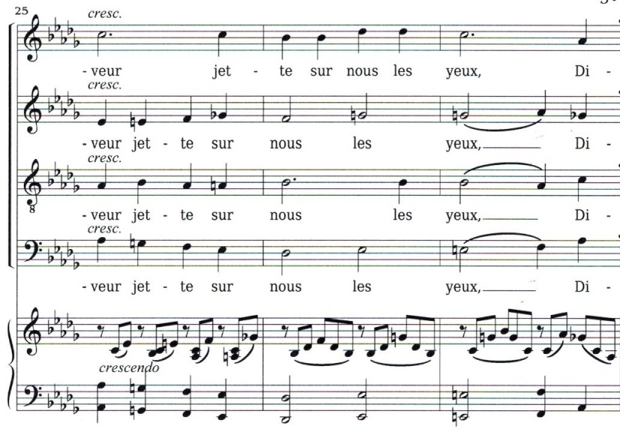
Figure 1

Figure 1 is an example of how Fauré used chromaticism to establish tension and expression of text. The alto line moves in contrary motion with the base line in ms. 25 and then in parallel thirds in ms. 26 using the G natural to establish the feeling of Ab major in ms. 31 (Figure 2).

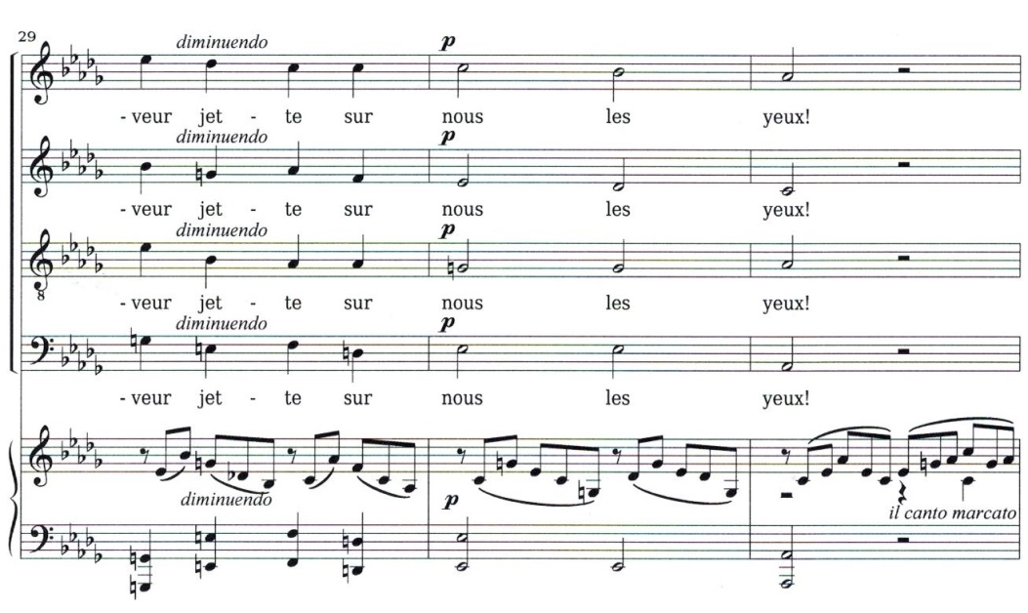
Figure 2

Figure 2 shows the importance of the seventh in establishing the tonal center and providing subtle tension. Although seventh chords are not necessary in establishing the tonal center, Fauré’s use of sevenths provides expressive tension and resolution throughout the entire piece. By the time we reach ms. 31 we are in the key of Ab (originally the dominant key of Db). Fauré uses G natural in the vocal lines as well as in the accompaniment to give a sense of leading to Ab. He also uses Db in ms. 29-30 as well as a passing D natural to help us feel Eb as the dominant of Ab major rather than as the ii chord of Db major. Another way Fauré establishes the new key is placing the tonic Ab in the bass line as well as three vocal lines. The only other times he does this is near the end of the piece in ms. 79 and again in the final measure when the melody concludes on Db, the original tonic (Figure 5). Prior to this the melody often followed the median such as in Figures 3 and 4.
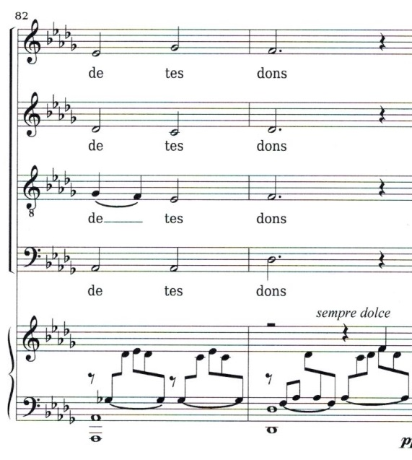
Figure 3

In Figure 3 the melody is supported by the dominant bass and follows the seventh (Gb) until resolving into the median of the tonic Db.

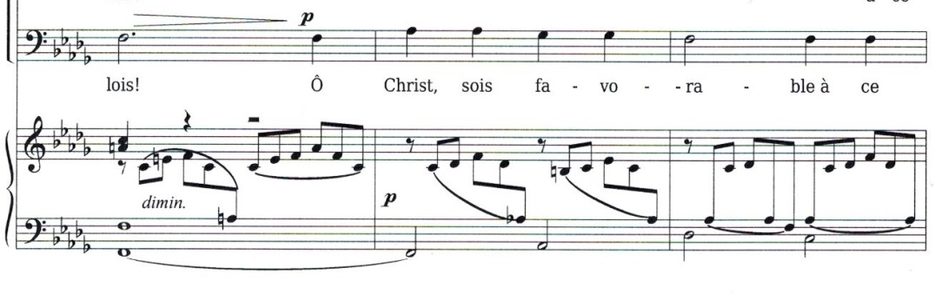
Figure 4

In Figure 4, the choral bass melody follows the median of the F minor chord in the second measure shown, the seventh of the Ab7 chord in the second half of the same measure, and returns to F, which is the median of the tonic Db.
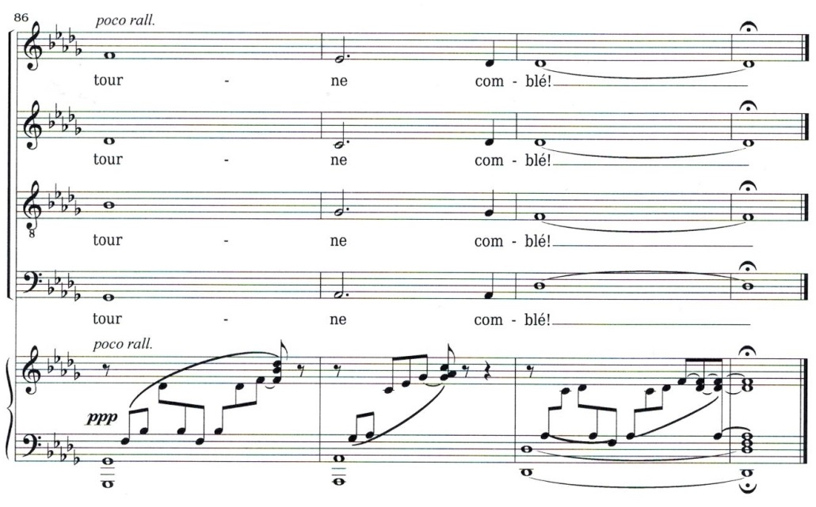
Figure 5

Figure 5 demonstrates the third time Fauré chooses to conclude a section or, in this case, the finale of the piece on the established tonic. Here you can see his IV7-V7-I cadence as well.

Fauré sets the piece in Db Major which is a difficult key for strings to play in. He arranged it originally for organ and orchestra, but it is mostly performed today with only orchestra. Writing the piece in Db major though inhibits the bass players from really laying down a really strong and low tonic. The Ab and dominant function of the key is lower and able to be played stronger. This subtly creates a nice flow from V to I that will be accentuated many more times in the piece.

Cantique de Jean Racine has a tempo marking of Andante (quarter = 80) with a meter marking of common time and a beginning style marking of cantablile. This slow walking tempo lends well to the significance of the text and the fullness of the organ and/or layering of orchestration. This tempo allows the rhythm, primarily quarter and half notes, to be given full attention which in turn brings increased lustre to the French sacred text. Cantabile, in a smooth singing style, is executed well at this tempo and the melodic line is able to reach its full potential of expression. At the beginning of the B section Fauré gave the style marking of dolce, sweetly, which is helpful in ensuring the interpretation of the text does not become marcato or even bombastic since the choir sings the same strong half note rhythmic pattern simultaneously. The style and tempo marking are typical of the Romantic period and the fact that the melody is easily singable and detectable as the melody are very characteristic not only of Romantic music but of Fauré.

The use of dynamic markings is very effective in this piece of music. The crescendi and decrescendi follow the vertical rise and fall of the melody and of the harmonic texture, lending to a natural build of sound as well as a diminishing of sound. The use of pp, p, mf and f also help to express the natural motion of the melody and accompanying harmonic movement which also helps in expressing the emotion and meaning of the text. The dynamic markings also make it more evident where the climactic places of the piece are: measure 28 as the words indicate “Divine Savior” resolving to “cast your eyes upon us”; measure 46 as the words “sound of Your voice” resolves to “disperse from any…” ; and finally to the main climax beginning in measure 55 “which induces it to forget your laws” and suddenly fading within one measure (59) as the texts beckons “Oh Christ, look with favor upon this faithful people”. Fauré also used subito in ms 47 and again in ms 75 which demonstrate the ideas of expression common during the Romantic period.

Cantique de Jean Racine is a sacred motet in ABA form. The end of the first A section (ms 31), prior to the interlude, concludes on the dominant V of Db major. The end of the last A section (ms 82-83) has the cadence of V7 to I followed by a coda which also ends V7-I. The B sections begins in ms 39 and does so as section A ended, in the dominant V of Db Major and features the strongest build of intensity beginning with the bass pickup to ms 52 and adding the other voices from the bottom up and repeats the same idea starting with the pickup to ms 56 with the same text and the same order of voices but at a forte rather than a mezzo forte. The B section concludes in F major (Figure 6) and immediately leads into the A section with the pickup to measure 60 and the original key of Db Major although the chordal structure in ms 60 cadences us into Db major in ms. 61. With accompaniment later being transcribed for orchestra, this change in the middle of the piece to Ab Major enables the string bass to create a strong execution of the Ab and Eb, which lends beautifully to the climax of the section before returning to Db. Perhaps the key of Db and the string bass unable to produce the strength on a Db but only the dominant Ab can be seen as an aural preparation for what would happen in the B section – a stronger Ab and its dominant Eb.

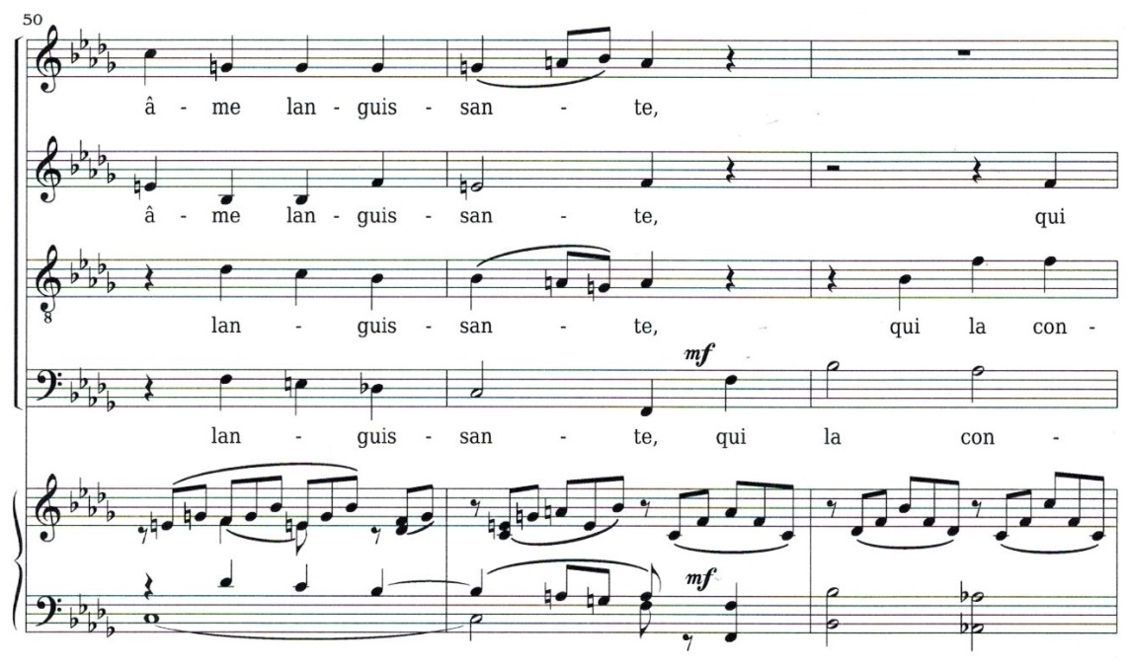
Figure 6

Figure 6 illustrates in ms. 51 the progression from C7 to F. In ms. 52 Fauré uses Bb minor (the vi of Db and the vii of Ab) as he begins to conclude section B.

Gabriel Fauré brilliantly incorporated rich texture, particularly in his use of seventh chords as well as moving thirds primarily between the melody and bass; and smooth flow of inner triplets throughout this piece to demonstrate the increased freedom of expression found during the Romantic period and at the beginning of the Modern era. He composed a haunting yet soothing melody which is capable of expressing the beauty of the sacred text through its contour. Fauré’s sensitive use of dynamics and the Andante tempo he selected for this piece is typical of the time period and displays Fauré’s understanding of the importance of musical text and melodic line. Cantique de Jean Racine is a beautiful musical marriage between composer and period with text and composition.

References
Garretson, Robert L. (1993). Choral Music – History, Style, and Performance Practice. Prentice Hall, Inc.

Robinson, Ray – editor. (1978). Choral Music – A Norton Historical Anthology. W.W. Norton & Company.

Choral Public Domain Library. http://www2.cpdl.org/wiki/index.php/Main_Page

Choral Public Domain Library. SCORE: http://www2.cpdl.org/wiki/images/sheet/faure/faur-can.pdf

Youtube.VIDEO: https://www.youtube.com/watch?v=wKwHiGg21KA&list=RDwKwHiGg21KA#t=0

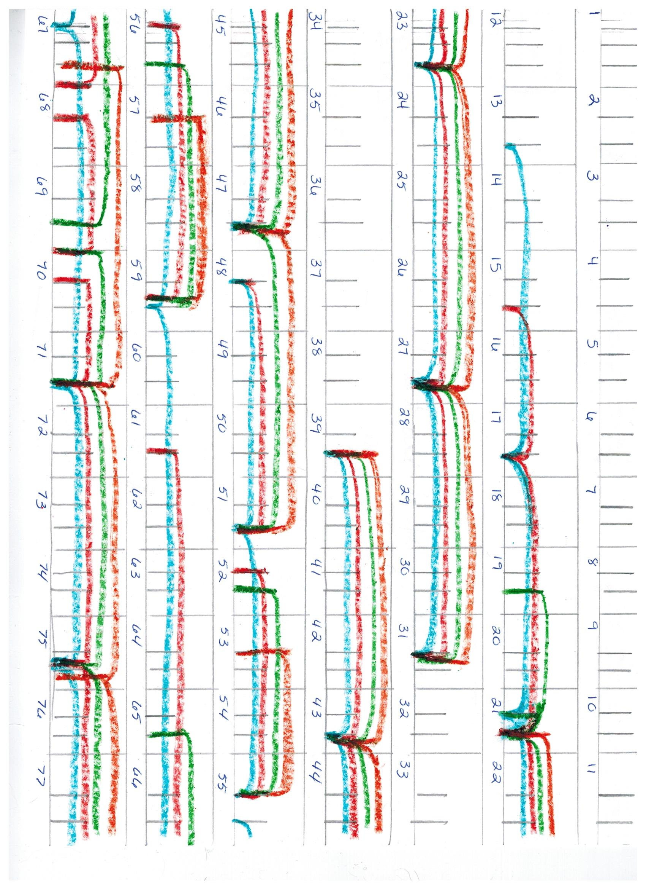
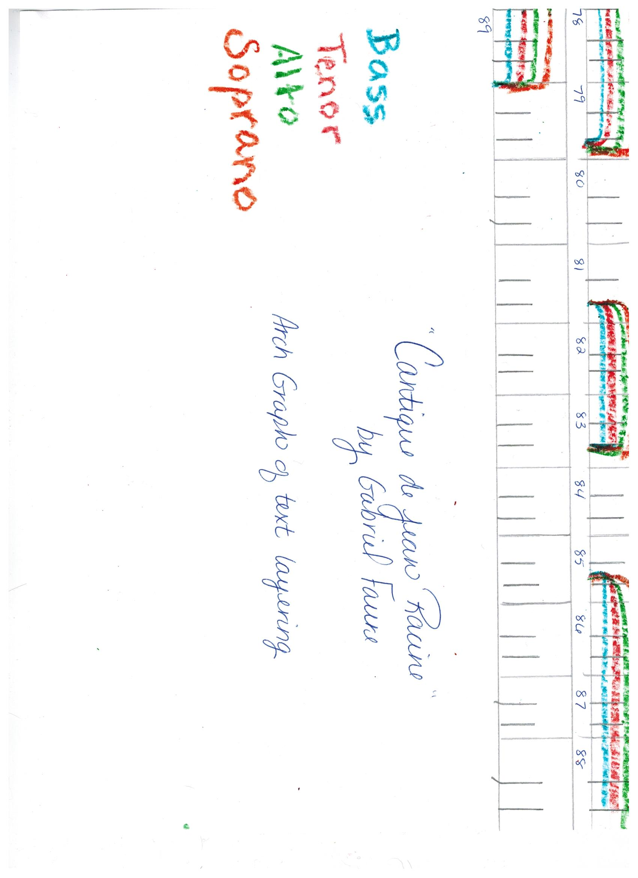
Cantique de Jean Racine by Gabriel Fauré
Key | Db Major
Time Signature | Common time
Form | ABA Form  Introduction ms 1-13  A section ms 13-29  Interlude ms 30-39  B section ms 39-59  A section ms 59-83  Coda ms 84-89
Genre | Sacred Motet
Voicing | SATB
Language | French
Dynamic Markings | ppp, pp, p, mf, f, subito, crescendo, decrescendo, diminuendo
Expression/Style Markings | Andante, Cantabile, Legato, il canto marcato, dolce, sempre dolce, poco rallantando
Period | Romantic
Instrumentation | Organ or piano; orchestra
Tempo | Andante (quarter note = 80)
Duration | Approximately 6:42

